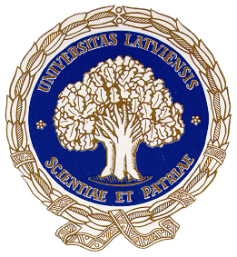  UNIVERSITY OF LATVIA | 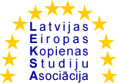  LATVIAN EUROPEAN COMMUNITY STUDIES ASSOCIATION

European Studies Students’ Forum Conference

European Union: Political, Economic, Legal and Social Aspects

December 7-8, 2005

Programme
Wednesday, 7 December
Venue: University of Latvia, Raiņa 19 Mazā Aula

17:45-18.15 Registration of the participants

18.15-18.30 OPENING OF THE CONFERENCE

Chair:
Mrs. Līga Sondore Students Forum Head, LECSA

Welcoming addresses

Mr. Indriķis Muižnieks Professor, Vice Rector in Research,
University of Latvia
Mrs. Tatyana Muravska Jean Monnet Professor, University of Latvia
LECSA President

KEYNOTE SPEECHES
Chair:
Mr. Morten Hansen Guest Professor SSE Riga,
LECSA Vice President

18:30–19.00 The British Presidency of the EU
H.E. Mr. Ian Andrew Minton Bond
Ambassador Extraordinary and Plenipotentiary of the United Kingdom

19:00-19:30 The Newest issues in the Relation of the Kingdom of Spain
with EU
H.E. Mr. Emilio Lorenzo Serra
Ambassador Extraordinary and Plenipotentiary of the Kingdom of Spain

19.30-20.00 The New Member States: From Policy Takers to Policy Makers?
Mr. Alf Vanags, Director
Baltic International Centre for Economic Policy Studies

20.15 Refreshments and discussion/ University cafeteria

